- \Operation\Basic settings\Settings
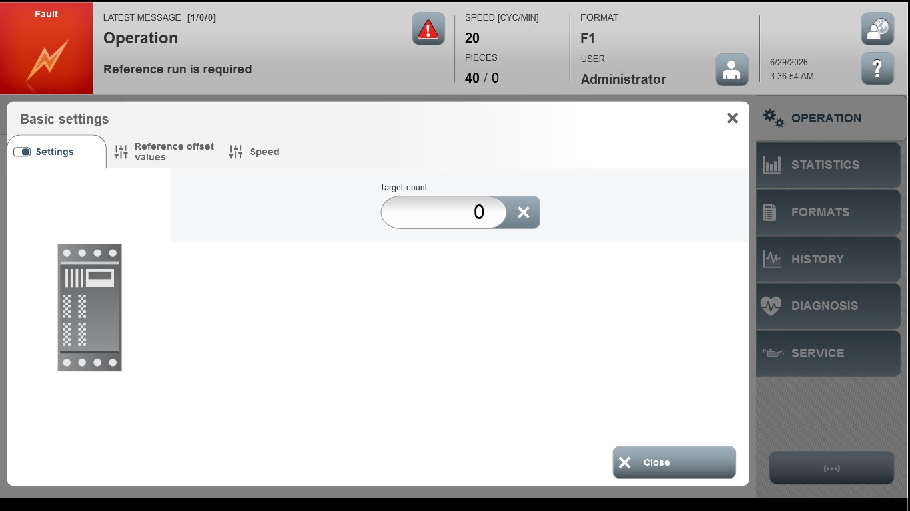
Acceptance criterion | Limits | Pass / Fail: Dev-No. | Date | Initials
Screen matches screenshot | N / A
Target count | 0…10000000

